Lesson 06 XAS Resource Workbook

**Vocabulary Words:**

**Dilute:** To be made less concentrated by mixing with something else. A dilute sample is one in which the element of interest makes up a very small percentage of the overall material.

**Isotropic:** Not varying in magnitude, regardless of the direction being measured. In most cases fluorescence is emitted randomly in all directions and is considered isotropic.

**Filter:** A material which removes unwanted radiation through preferential absorption. These are often used to reduce the background from x-rays which scatter off the sample.

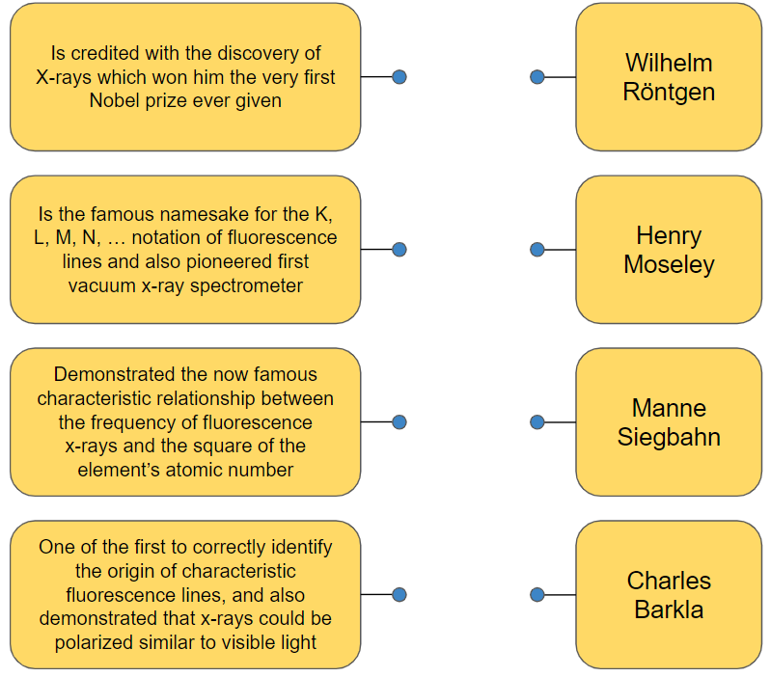**Exercise:**  Below are four Nobel laureates who all made significant contributions to the early discoveries and theories surrounding x-ray physics. Draw a line from each laureate to their respective contribution.

**Exercise:**  Complete the crossword puzzle below.

